St. Ann’s Church
323 S. 15th Street, Sebring, Ohio

FROZEN PIEROGI SALE
JULY 17, 2020
2:00 – 6:00 PM

Potato, Sauerkraut, Jalapeno
$7.50 PER DOZEN

Frozen Apple Fritters
$1.00/each

Selling till they are gone!

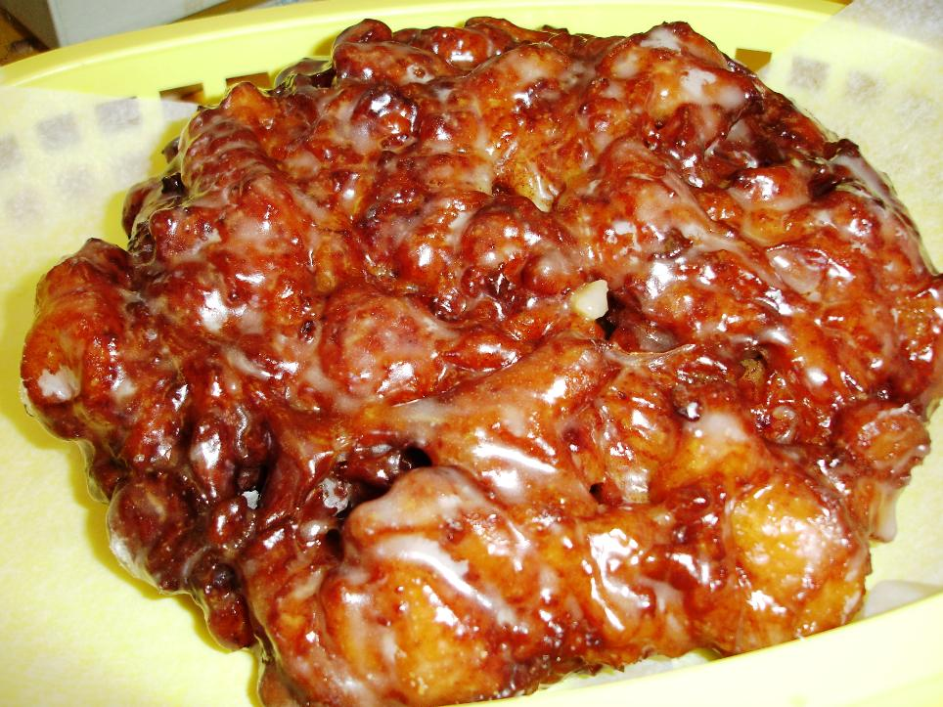
Call ahead 330-938-2033 to pre-order and prepay with credit card.

